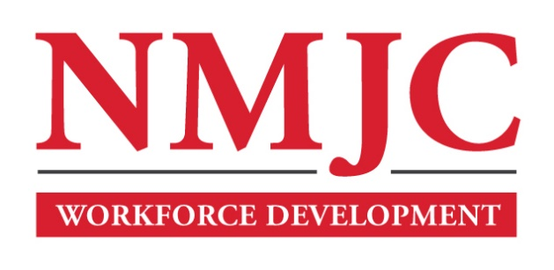
Pharmacy Technician Program – NMJC Workforce Development
Tuition - $1,500; Total Hours – 50 classroom + 80 clinical externship
Location 5317 N. Lovington Hwy, Hobbs, NM 88240

Tuesday January 20 6:00pm - 9:30pm
Thursday January 22 6:00pm - 9:30pm

Tuesday January 27 6:00pm - 9:30pm
Thursday January 29 6:00pm - 9:30pm

Tuesday February 3 6:00pm - 9:30pm
Thursday February 5 6:00pm - 9:30pm

Tuesday February 10 6:00pm - 9:30pm
Thursday February 12 6:00pm - 9:30pm

Tuesday February 17 6:00pm - 9:30pm
Thursday February 19 6:00pm - 9:30pm

Tuesday February 24 6:00pm - 9:30pm
Thursday February 26 6:00pm - 9:30pm

Tuesday March 3 6:00pm - 9:30pm
Thursday March 5 6:00pm - 9:30pm

Tuesday March 10 6:00pm - 9:30pm

