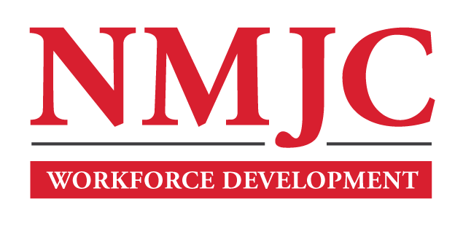
Pharmacy Technician Program – NMJC – Training & Outreach
Tuition - $1,400; Total Hours – 50 classroom + 80 clinical externship
Location 5317 N. Lovington Hwy, Hobbs, NM 88240

Tuesday September 24 6:00pm - 9:30pm
Thursday September 26 6:00pm - 9:30pm

Tuesday October 1 6:00pm - 9:30pm
Thursday October 3 6:00pm - 9:30pm

Tuesday October 8 6:00pm - 9:30pm
Thursday October 10 6:00pm - 9:30pm

Tuesday October 15 6:00pm - 9:30pm
Thursday October 17 6:00pm - 9:30pm

Tuesday October 22 6:00pm - 9:30pm
Thursday October 24 6:00pm - 9:30pm

Tuesday October 29 6:00pm - 9:30pm
Thursday October 31 6:00pm - 9:30pm

Tuesday November 5 6:00pm - 9:30pm
Thursday November 7 6:00pm - 9:30pm

Tuesday November 12 6:00pm - 9:30pm

