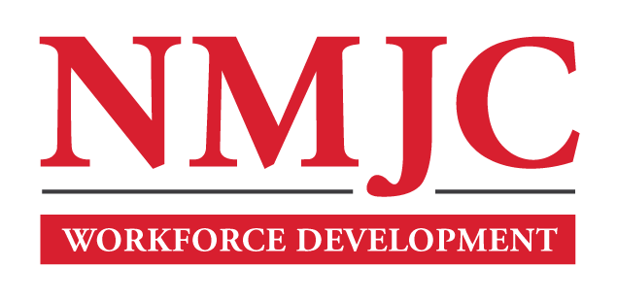
Dental Assisting Program – NMJC – Training & Outreach
Tuition - $1,200; Total Hours – 60
Location 5317 N. Lovington Hwy, Hobbs, NM 88240

Monday October 7 6:00pm - 9:30pm
Wednesday October 9 6:00pm - 9:30pm

Monday October 14 6:00pm - 9:30pm
Wednesday October 16 6:00pm - 9:30pm

Monday October 21 6:00pm - 9:30pm
Wednesday October 23 6:00pm - 9:30pm

Monday October 28 6:00pm - 9:30pm
Wednesday October 30 6:00pm - 9:30pm

Monday November 4 6:00pm - 9:30pm
Wednesday November 6 6:00pm - 9:30pm

Monday November 11 6:00pm - 9:30pm
Wednesday November 13 6:00pm - 9:30pm

Monday November 18 6:00pm - 9:30pm
Wednesday November 20 6:00pm - 9:30pm

NO CLASS November 25 NO CLASS
NO CLASS November 27 NO CLASS

Monday December 2 6:00pm - 9:30pm
Wednesday December 4 6:00pm - 9:30pm

Monday December 9 6:00pm - 9:30pm
Wednesday December 11 6:00pm - 9:30pm

