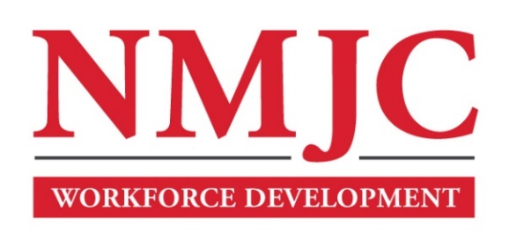
Clinical Medical Assistant Program – NMJC – Training & Outreach
Tuition - $2,700; Total Hours – 140 classroom + 160 hours clinical time
Location: 5317 N. Lovington Hwy, Hobbs, NM 88240

Tuesday August 27 6:00pm - 9:30pm
Thursday August 29 6:00pm - 9:30pm

Tuesday September 3 6:00pm - 9:30pm
Thursday September 5 6:00pm - 9:30pm
Saturday September 7 9:00am - 4:30pm

Tuesday September 10 6:00pm - 9:30pm
Thursday September 12 6:00pm - 9:30pm

Tuesday September 17 6:00pm - 9:30pm
Thursday September 19 6:00pm - 9:30pm
Saturday September 21 9:00am - 4:30pm

Tuesday September 24 6:00pm - 9:30pm
Thursday September 26 6:00pm - 9:30pm

Tuesday October 1 6:00pm - 9:30pm
Thursday October 3 6:00pm - 9:30pm
Saturday October 5 9:00am - 4:30pm

Tuesday October 8 6:00pm - 9:30pm
Thursday October 10 6:00pm - 9:30pm

Tuesday October 15 6:00pm - 9:30pm
Thursday October 17 6:00pm - 9:30pm
Saturday October 19 9:00am - 4:30pm

Tuesday October 22 6:00pm - 9:30pm
Thursday October 24 6:00pm - 9:30pm

Tuesday October 29 6:00pm - 9:30pm
Thursday October 31 6:00pm - 9:30pm
Saturday November 2 9:00am - 4:30pm

Tuesday November 5 6:00pm - 9:30pm
Thursday November 7 6:00pm - 9:30pm

Tuesday November 12 6:00pm - 9:30pm
Thursday November 14 6:00pm - 9:30pm
Saturday November 16 9:00am - 4:30pm

Tuesday November 19 6:00pm - 9:30pm
Thursday November 21 6:00pm - 9:30pm

NO CLASS November 26 NO CLASS
NO CLASS November 28 NO CLASS

Tuesday December 3 6:00pm - 9:30pm
Thursday December 5 6:00pm - 9:30pm

