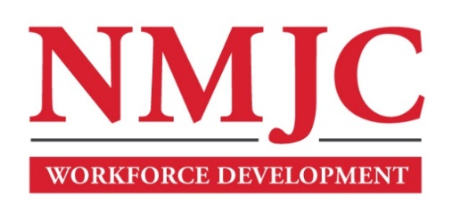
Clinical Medical Assistant Program – NMJC – Training & Outreach
Tuition - $2,700; Total Hours – 140 classroom + 160 hours clinical time
Location: 5317 N. Lovington Hwy, Hobbs, NM 88240
Monday January 27 6:00pm - 9:30pm
Wednesday January 29 6:00pm - 9:30pm

Monday February 3 6:00pm - 9:30pm
Wednesday February 5 6:00pm - 9:30pm
Saturday February 8 9:00am - 4:30pm

Monday February 10 6:00pm - 9:30pm
Wednesday February 12 6:00pm - 9:30pm

NO CLASS February 17 NO CLASS
Wednesday February 19 6:00pm - 9:30pm

Monday February 24 6:00pm - 9:30pm
Wednesday February 26 6:00pm - 9:30pm
Saturday March 1 9:00am - 4:30pm

Monday March 3 6:00pm - 9:30pm
Wednesday March 5 6:00pm - 9:30pm
Saturday March 8 9:00am - 4:30pm

Monday March 10 6:00pm - 9:30pm
Wednesday March 12 6:00pm - 9:30pm

NO CLASS March 17-21 NO CLASS

Monday March 24 6:00pm - 9:30pm
Wednesday March 26 6:00pm - 9:30pm
Saturday March 29 9:00am - 4:30pm

Monday March 31 6:00pm - 9:30pm
Wednesday April 2 6:00pm - 9:30pm

Monday April 7 6:00pm - 9:30pm
Wednesday April 9 6:00pm - 9:30pm
Saturday April 12 9:00am - 4:30pm

Monday April 14 6:00pm - 9:30pm
Wednesday April 16 6:00pm - 9:30pm

Monday April 21 6:00pm - 9:30pm
Wednesday April 23 6:00pm - 9:30pm

Monday April 28 6:00pm - 9:30pm
Wednesday April 30 6:00pm - 9:30pm
Saturday May 3 9:00am - 4:30pm

Monday May 5 6:00pm - 9:30pm
Wednesday May 7 6:00pm - 9:30pm

Monday May 12 6:00pm - 9:30pm

